First Quarter

Honor Roll

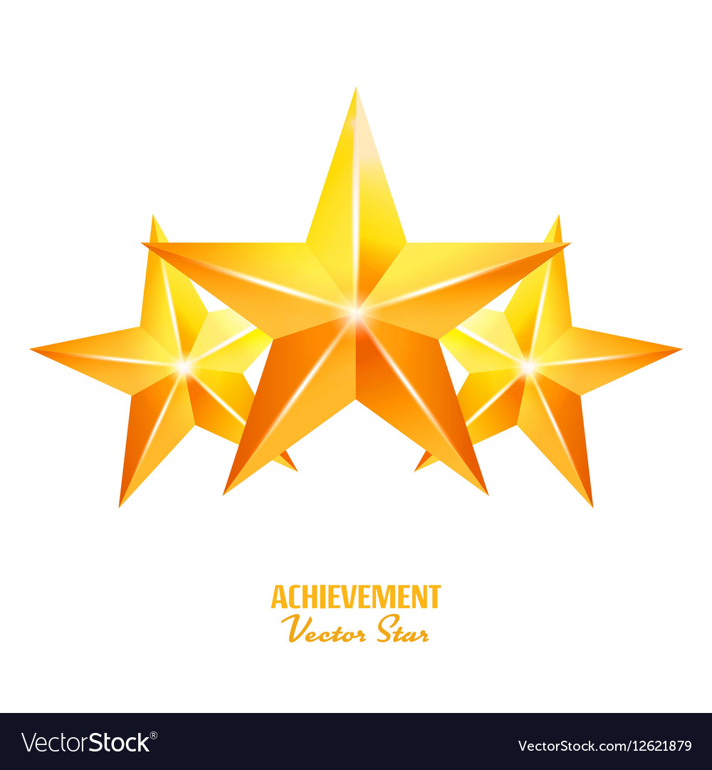8th Grade

Aisha Abdi Fatuma Abdikadir

Amera Abdullahi Prosper Addae

Aatika Ahmad Kennedy Bell

Wendy Cabrera Psalms Clark-Henry

Yandry Clavijo Salas Sole' Ervin

Jayden Evans Dagmawit Ghebresilassie

Ayanna Gibbs Jayda Green

Naleigha Jackson Hayden Jones

Kamryn Jones William Knechtly

Jena Leach Daniela Lulu

First Quarter

Honor Roll

8th Grade Cont.

Hawa Malkat Mahamud Jalexis Mattos Avalos

Karmela Mea Mina Azimir Moore

Caleb Mullins Curtis Mullins

Lily Mwenebyane Aiden Norton

Dirielys Rivera Henriquez Mia Salinas Gloria

Christian Santiago Galicia Wesley Townsend

Elijah Williams